COMHAIRLE CHONTAE LONGFOIRT

LONGFORD COUNTY COUNCIL

Corporate Affairs,
Aras an Chontae,
LONGFOIRT.

1u Aibreain 2015.

Chuig: Gach Ball don Chomhairle.

A Chomhairleoir,

Iarrtar ort bheith i láthair ag Cruinniú Míosuil Chomhairle Chontae Longfoirt a tionólfar i Seomra na Comhairle, Aras an Chontae, Longfoirt ar an Chéadaoin,
8u Aibreain 2015 ag 4.00 p.m chun gnó a dhéanamh d’réir an Chláir thíos.

You are requested to attend the Monthly Meeting of Longford County Council to be held in the Council Chamber, Aras an Chontae, Great Water Street, Longford, on Wednesday, 8th April 2015 at 4.00 p.m. to transact business, as set out on the Agenda hereunder.

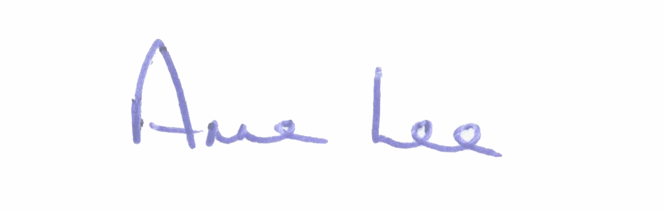
Mise le meas,

_______________
Anne Lee,
Meetings Administrator.

C L A R

Prayer before Meeting.

- Confirmation of Minutes of Monthly Meeting held on 11th March 2015 -
copy enclosed.

2. Matters arising from Minutes.

3. To note adopted Minutes of Corporate Policy Group Meeting held on
11th February 2015 - copy enclosed.

4. To note Chief Executive Orders. (Summary herewith).

5. To note Monthly Management Report - report enclosed.

6. Finance & Information Systems, Housing & Building.

(a) To note Public Liability Claims received during March 2015 – report enclosed.

- Consideration of Annual Financial Statement 2014 - enclosed.

- Consideration of Approval to Additional Expenditure under S104(7)
of the Local Government Act 2001 – details enclosed.

7. Infrastructural, Environmental & Emergency Services.

- To approve agreement between Longford County Council and Kildare
County Council in accordance with Section 85 of the Local Government
Act 2001, in relation to essential bridge rehabilitation works on three
bridges in County Longford - report enclosed.

8. Economic and Community Development, Corporate, Cultural & Recreational Services, Human Resources, Planning & Building Control.

- To note Planning Applications received since March meeting of the Council.

- Proposed Regeneration Plan for Longford.

- Consideration of Draft Annual Report 2014 prepared in accordance with Section 21 of Local Government Act 2001.
- to follow.

- Presentation regarding Longford Blueway Festival -
24th to 26th April 2015.

- Consideration of update on 1916 Commemoration.

9. General.

- Correspondence.

- Letter dated 10th March 2015 received from the Office of the Minister for Health regarding Longford/Westmeath Hospital.
- Letter dated 13th March 2015 received from the Office of the Minister for the Environment, Community and Local Government regarding funding for emergency homeless accommodation at St. Martha’s House and Bethany House, Longford.
- Letter dated 20th March 2015 received from the Office of the Minister for Finance regarding Rates Legislation.
- Letter dated 30th March 2015 received from the Office of the Minister for Public Expenditure and Reform regarding rates legislation.
(copies enclosed)

10. Votes of sympathy.

11. Conferences -

Consideration of Report from Corporate Policy Group.

